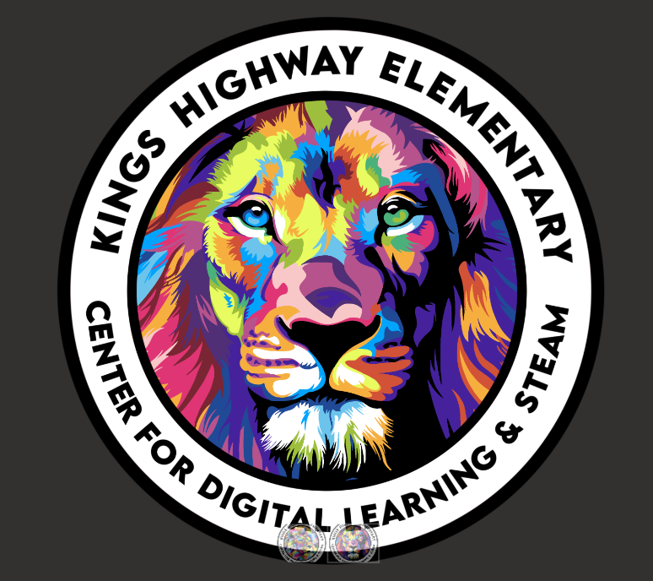**Pinellas County Schools**

**Magnet Agreement**

**for Kings Highway Elementary School**

**Center for Digital Learning & STEAM**

**2025-26**

Student’s Name: _______________________________

Teacher’s Name: _______________________________ Date of Initiation Signing: ________Date of Mid-year Signing: _______

As the **parent/guardian** of a student in this magnet program, I agree to:

* Ensure that my child attends school daily and on time (in class by 8:45am or marked tardy)
* Ensure that my child is picked up on time at dismissal (2:55)
* Support high expectations for both academics and behavior
* Support participation in all magnet activities including STEAM clubs, STEAM Projects, Digital Citizenship, Digital Learning, and Family Events
* Update the school with current contact and medical information immediately after information changes
* Assist the school in promoting safe, responsible, respectful, and kind behavior
* Communicate with my child’s teacher(s) to support learning. (FOCUS, Agenda /Phone, Email, Conference)
* Support all school policies and procedures
* Ensure that my child wears the appropriate school uniform

Parent Signature(s): ________________________________________________________________________

As a **student** in this magnet program, I agree to:

* Attend school every day ready to learn and do my best to meet my academic goals
* Participate in all class and magnet program/STEAM activities
  + KHEMS students are expected to demonstrate conscientious academic effort by regularly completing assignments and by participating appropriately in lessons, activities, and assessments. Students should be self-motivated, able to work cooperatively with others, solve problems creatively, and should enjoy hands-on activities. In addition to the above, STEAM magnet students are expected to fulfill academic requirements related to the magnet theme in order to maintain active status and continue to the next grade level in the magnet program. This includes completing STEAM projects and attending STEAM clubs.
* Follow the “Lion Way” while on campus, including classrooms, hallways, cafeteria, Music, Art, and PE areas. I will be SAFE, RESPONSIBLE, RESPECTFUL, and KIND, including accepting responsibility for my own actions. I will show the Four Positive Habits: #1- I Am in Charge of My Choices, #2- Fuel Up with Positive Energy, #3- No Bullying, #4- Think Win-Win
* Have cell phones and/or any other communication devices out of sight and powered off throughout the entire school day, and not powered back on until leaving school grounds

Student Signature: _________________________________________________

Parent Signature: ___________________________________________________

**Elementary Magnet Procedure for Possible Removal from the Program**

It is expected that all students in the KHEMS magnet program will be behaviorally successful.

An Intervention Committee (IC) reviews cases, suggests interventions that will increase student success, and recommends probation and removal from the magnet program for students who are not being successful meeting KHEMS expectations.